1. QR CODE

So the user will have to scan the QR code in order to get the clue for this round. Upon scanning the code, he/she will get the following message

Dumbells are used by experianced and persevarant fitness freak.

Notice the letter errors in the above (often mistaken words)

Dumbbells: b was left

Experienced : e was left

Perseverant : e was left

Freaks : should be s.

Answer becomes bees.

To make it more tough we can have some encryption to hide the QR code also.

--------------------------------------------------------------------------------------------------------------------------

1. Next level we can make use of this web template

<https://codepen.io/haidang/pen/WEyrvj>

On this template wherever the user clicks he is directed to a page where the message prompts

“ERROR 404. DNS BROWSER NOT FOUND.”

If you observe carefully this is a wrong message it is always a dns server but many wouldn’t notice that. The word browser and the fire actually are hints.

In the source code we will hide “/hankuro/pen/QMVLJZ” this link in comments. This link will have to be pasted after the codepen.io in the previous link to get <https://codepen.io/hankuro/pen/QMVLJZ>

To get the wolf template ( can be changed to a fox like we can create this codepen template from our account.)

So the answer becomes Mozilla Firefox.

----------------------------------------------------------------------------------------------------------------

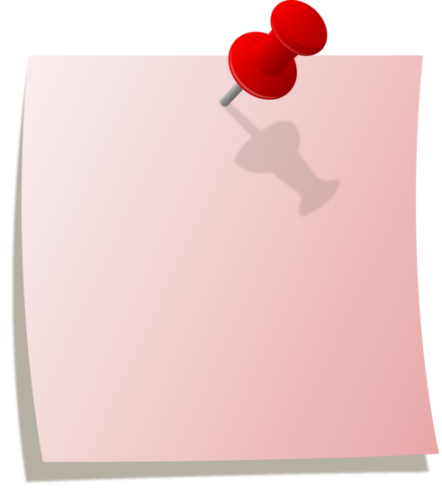C:\Users\pandepce\Downloads\image.jpg

In the next level using photo editing app we are going to paste the above route (map)on the pinned note. On either ends of the route we will edit to make a start and a finish word.

We have to enrypt “**Sijo_pali** “somewhere on the page. Basiaclly he is a photographer and he has pics from various places in india. The above map is of Jammu and Kashmir. So the player will have to search for sijo pali , go to his pininterest or insta and then find out a picture from Kashmir.

------------------------------------------------------------------------------------------------------

1. Morse code

Half-son of Hephaestus loved this language. Didn’t he?

-.-. / --- / -. / --. / .-. / .- / - / ..- / .-.. / .- / - / .. / --- / -. / ...

Answer : Congratulations.

---------------------------------------------------------------------

1. We can have a line that says “Carefully observe and **write answer**.” We can several popups ,images and stuff to mislead. But finally the answer should be “answer” only :P

--------------------------------------------------------------------------------

1. In the next level , we can extract the audio from this youtube link:

<https://www.youtube.com/watch?v=Bj7ycgOlIWw>

This is the youtube song.

With this as the background music,

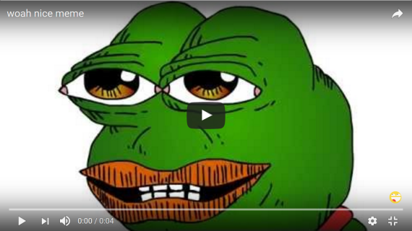

We will extract the above picture from the youtube video (“Woah nice meme”) for the background image.

The user will be fooled with various comments in the source code that talk about a “nice frog”.

And as a footer of this page we can have the name of “Trevon Johnson” (The actual singer for the youtube song.)

So basically they will have to think that this pic has to be searched for on the youtube. In hints we can indirectly tell them about the memes and all.

They will have to paste the url of the video as the answer.

The url is <https://www.youtube.com/watch?v=oc3dG9jArWs>

-------------------------------------------------------------------------------------------------------------------------------

7.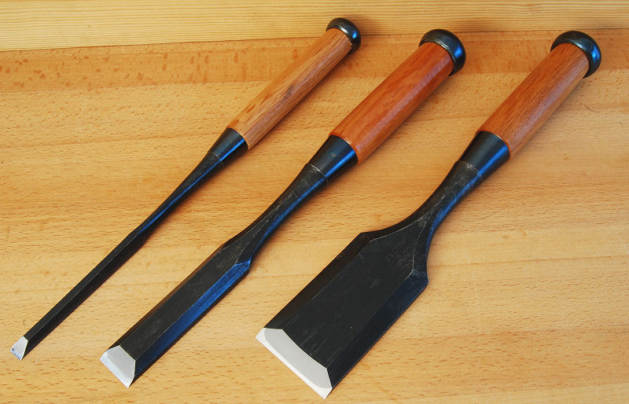

I think we should hide tools like this on the webpage. As in we can have a code language for few tools like for four tools or so. After which they will have to understand they are **edge tools**. The word edge can be hidden in the url.

We have to think of the way that user writes the anagram for edge tools : GOOD STEEL

---------------------------------------------------------------------------------------------------------

8. 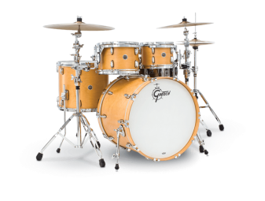 

We can photoshop three pics in such a way that either of them comes on top of the other. Or like the person is shooting the drums with the flag sticker on it. We should create an element or a simple hover at some element or a click which should produce the word Fate.

So there is a movie called the Drums of fate. (Not many know)

In his movie the cinematographer was a American-chinese man called “ James Wong Howe”

-------------------------------------------------------------------------------------------------------------------------------

09.



We will photoshop and write on the image a quote.( Made by me but we will pretend :P)

The quote is

“**Face it**! And see your life taking a turn towards success. Because if it doesn’t challenge you, it doesn’t change you.”

* Opuesto

So in here we pretend that this quote is by opuesto but it is just the Spanish word for opposite. This quote is for the coward people. And how do we know that? Yes from the quote itself and also the image.

A phrase called “ Yellow streak” means cowardice.

And the answer would be opuesto of yellow streak that is courage/couragrous/hero.

----------------------------------------------------------------------------------------------------------------------------

10.http://www.dcode.fr/tools/wingdings/images/char(100).pnghttp://www.dcode.fr/tools/wingdings/images/char(105).pnghttp://www.dcode.fr/tools/wingdings/images/char(100).pnghttp://www.dcode.fr/tools/wingdings/images/char(32).pnghttp://www.dcode.fr/tools/wingdings/images/char(117).pnghttp://www.dcode.fr/tools/wingdings/images/char(32).pnghttp://www.dcode.fr/tools/wingdings/images/char(101).pnghttp://www.dcode.fr/tools/wingdings/images/char(97).pnghttp://www.dcode.fr/tools/wingdings/images/char(116).pnghttp://www.dcode.fr/tools/wingdings/images/char(32).pnghttp://www.dcode.fr/tools/wingdings/images/char(50).pnghttp://www.dcode.fr/tools/wingdings/images/char(63).png

These will be the symbols on the screen. They are windings alphabets.

The translation of this is

“Did you eat 2?”

To confuse we can have stuff like “click here to know more type things about omega,diamond symbol and stuff.

------------------------------------------------------------------------------------------------------------------------------------------